(Approx. 322 words)

It’s Called Clickbait, and You Need to Learn to Avoid It
By Kurt Jefferson, Editor, Central Kentucky Computer Society
https://www.ckcs.org
lextown2 (at) gmail.com

I was eating yogurt as I was reading stories about one growing danger on the Web: Clickbait. What I read made me pause and put down my spoon.

It turns out that plenty of us are clicking on email links or Facebook postings sent to us from unknown senders. Unfortunately, this can lead to malware and trojan horses infecting your computer.

The practice is called clickbait. Someone you don’t know sends you an email or a Facebook posting. It contains a link. You click on it.

Catchy and provocative headlines are usually a dead giveaway that you’re being targeted by clickbait.

Clickbait often contains these qualities:

• Headlines that appeal to your strong emotions, such as humor or outrage

• Headlines designed to grab your attention, leaving you wanting more information

• Headlines that tell you nothing about the content of the article

• The headline is too good to be true

• Content that encourages you to share the item with someone else on Facebook

• Funny images or video

Examples of clickbait headlines include:

87–Year–Old Trainer Shares Secrets to Losing Weight

When You Read These Shocking Food Facts, You’ll Never Want to Eat Again

Stop Eating Chicken Breasts Immediately

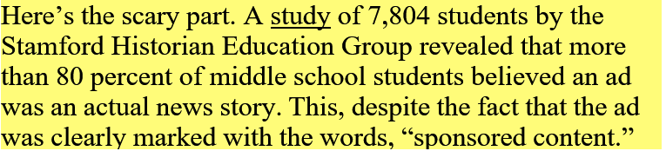
The point is to teach people to recognize clickbait and to avoid it. It’s not worth your time.

Free IQ tests and credit score checks often ask you to fill in personal information. Unfortunately, you don’t know that the website collects your personal details to build a profile on you. Once you submit this information, you’ll be subjected to scams and even more links to dangerous websites.

Clickbait links open the door to more spam and potential malware, adware, spyware, viruses, worms, trojan horses, and the real possibility that someone could take over control of your computer. Just say no by refusing to click on links you aren’t sure about.

